DAYS CREEK CHARTER SCHOOL
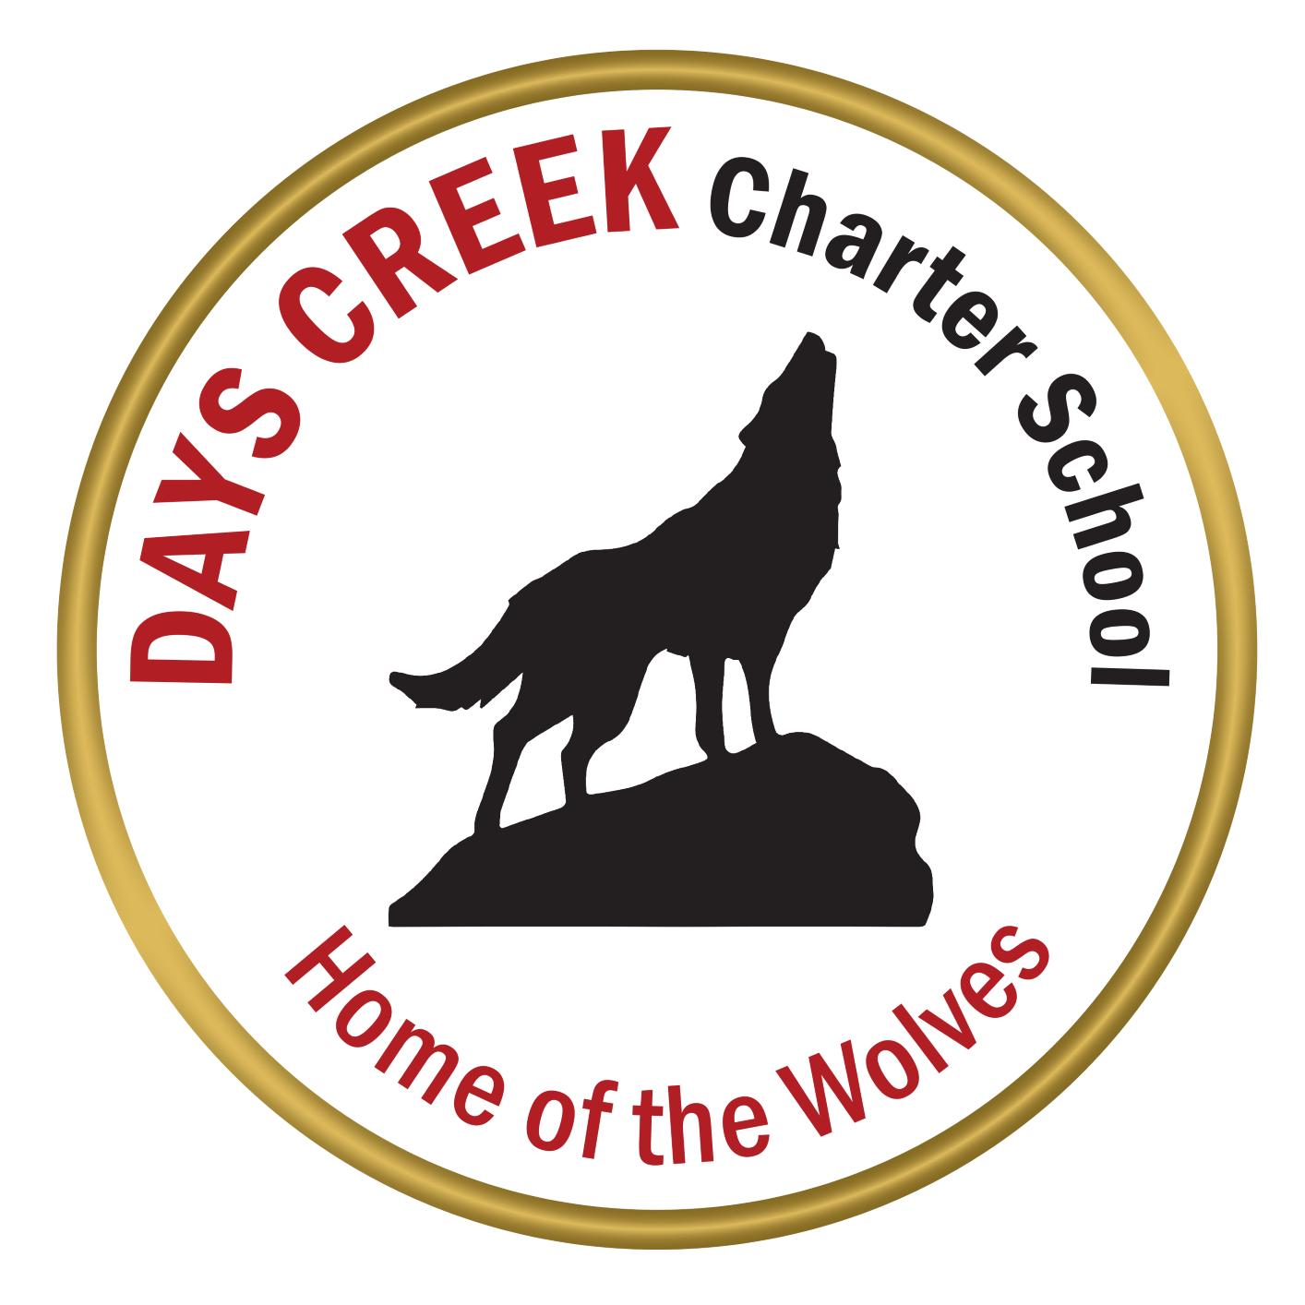

COMMUNITY SERVICE MANUAL
Revised 11-06-2019

Community Service Hours
Days Creek Charter School students are required to complete 80 hours of community service during their high school years. You should complete a minimum of 20 hours each year: 20 hours by June of your freshman year; 20 more hours (total of 40 hours) by June of your sophomore year; 20 more hours (total of 60 hours) by June of your junior year; and 20 more hours (total of 80 hours) by the end of Quarter 3 your senior year. These community service hours may be completed during the school year or in the summer.
Community Service Ideas
There are many opportunities for you to volunteer and acquire the necessary community service hours. If you are unsure whether or not an activity can be used towards community service hours, refer to administration or the adopted community service list (see below). You are required to keep a log and get the appropriate signatures for completing the hours. Volunteering for and/or having immediate family members sign off for community service hours is not allowed.
Days Creek Community Service Hours Opportunities
Grading
Your community service hours will be an assignment as part of your English course and points will be given according to the number of hours you complete. If you complete all your hours, you will receive full credit. If you do not complete all your assigned 20 hours you will have points deducted from assignments grade. The hours you do not complete will be added to the next year's total. Example: If you complete 15 hours in your freshman year, 5 hours will be added onto your total for your sophomore year. As a result, you would need to complete 25 hours during your sophomore year.
Community Service Time Log
Describe the activities in the time log and indicate how much time you devoted to each. Obtain a signature from an adult such as a supervisor, teacher, or mentor to verify the amount of time worked. Turn in a copy of this time log to show what you’ve done to date at the end of each semester. You may also turn any completed time log’s in as they are completed. Your time logs will be turned into your English teacher and will be entered into Synergy to track the total amount of hours you have completed. Keep a copy of all your time logs.
Grade Level | Class Responsible | Due Dates
9th | Freshman Orientation & English I * | End of the last day of the school year
10th | Modern World History * | End of the last day of the school year
11th | English III * | End of the last day of the school year
12th | Senior Capstone Class * | Coincide with Capstone Project due date
*Or as assigned by admin
Community Service Time Log

Describe the community service/project activity | Time on activity:
1.
Adult signature to verify time spent on activity 1:

2.
Adult signature to verify time spent on activity 2:
3.
Adult signature to verify time spent on activity 3:
4.
Adult signature to verify time spent on activity 4:

TOTAL AMOUNT OF TIME DEVOTED TO COMMUNITY SERVICE:

*Track hours of service using this log. The log must be given to the school office for credit to be awarded.

